**Caerwent Village Hall Booking Form**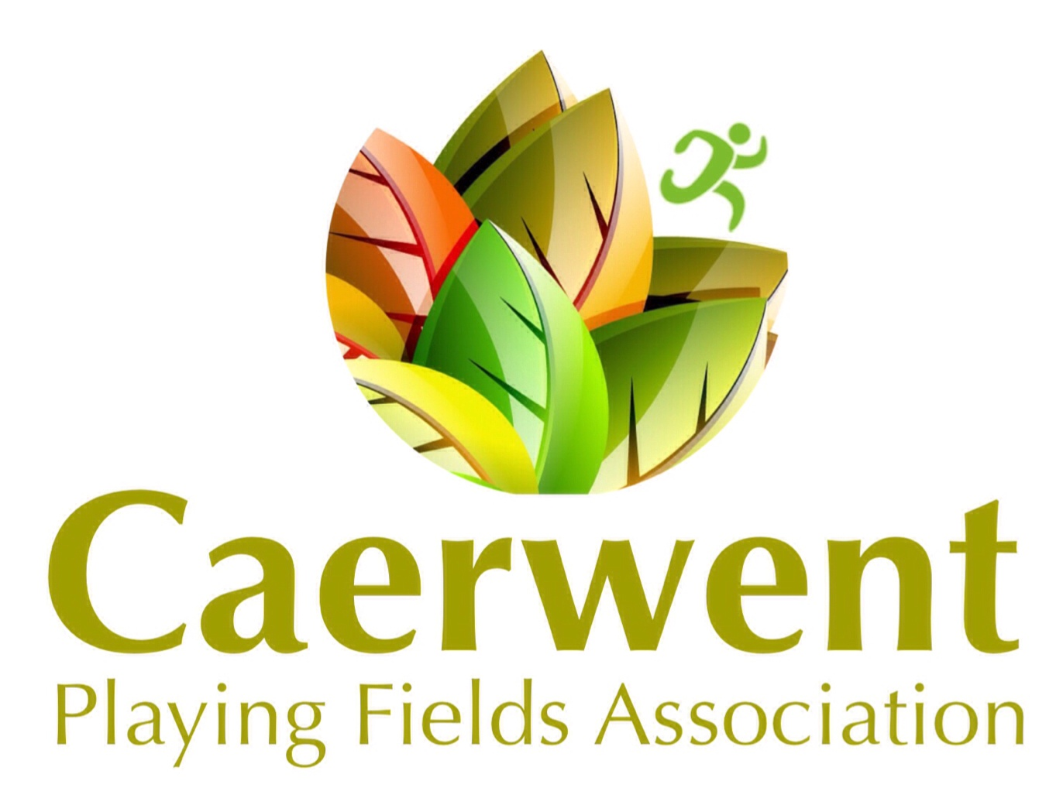

Application for the use of the village hall must be made on the booking form.

|  |  |  |  |
| --- | --- | --- | --- |
| Booking Reference |  | | |
| Name |  | | |
| Address |  | | |
| Telephone Number |  | | |
| Email Address |  | | |
| Start date of Hire |  | Finish date of Hire |  |
| Start time of Hire |  | Finish time of Hire |  |
| Purpose of Hire |  | | |
| Approximate Numbers Attending |  |  |  |
| Facilities needed | Hall Yes/No | Kitchen Yes/No | Bar Area Yes/No |
|  | Tables Yes/No | Chairs Yes/No | Licensed Bar Y/N |
| Facilities you will provide | Food Prep Yes/No | Own Music Yes/No | Own Bar Y/N *** |
| Caerwent Community Resident (Please circle) |  |  |  |
| Payment Method (Please circle) | Cash | Cheque | PayPal |
| Hire Fee (to be returned with this Booking Form | £ |  | BACS |
| Alcohol Licence  Application supplement (to be returned with this booking form) | £0 |  |  |
| Refundable Deposit (to be returned with this booking form) | £0 |  |  |
| Total Hire cost (to be returned with this booking form) | = SUM(B15:B17) \# "0" \* MERGEFORMAT0 |  |  |

***NB The Hirer is to inform CPFA if it is proposed that alcoholic drinks are to be available at the event. No retail sale of alcohol may be undertaken by the Hirer except with the permission of CPFA the arrangements to be discussed and agreed by CPFA. Where CPFA so decides, the Hirer may be required by CPFA to apply for a Temporary Event Notice (TEN) A £20 additional charge is levied as a contribution towards licence fees. A £400 refundable deposit is payable for all events where alcohol will be sold.

PERMISSION FOR 16TH, 18TH AND 21ST BIRTHDAYS MUST BE SOUGHT PRIOR TO BOOKING

Bookings can only be made by the return of this form with payment of the indicated fee

Please see our hire rates online [www.caerwentplayingfields.com/hire.html](http://www.caerwentplayingfields.com/hire.html)

Returning this form to the booking clerk confirms that you have read a copy of our Terms and Conditions of Hire and have understood them and agree to abide by them.

Signed Dated

Cancellation of any hire agreement will be considered as per our terms and conditions which will be provided at the time of booking